Phishing Detection Tool Using Machine Learning

Project submitted for the partial fulfillment of the requirements for the course

CSE 460 - WEB APPLICATION PENETRATION TESTING
Offered by the
Department Computer Science and Engineering
School of Engineering and Sciences
Submitted by
Tejaswi Darsi-AP22110011503


Under the Guidance of
Dr. Bhaskara Santosh Egala

SRM University–AP
Neerukonda, Mangalagiri, Guntur
Andhra Pradesh – 522 240
[April, 2025]

Table of Contents
- Introduction
- Problem Statement
- Tools and Technologies Used
- Methodology
4.1 Email Phishing Detection
4.2 URL Phishing Detection
- How the Solution is Achieved
- System Architecture
- Impact of the Problem if It Is Not Solved
- Results and Analysis
- Conclusion
- References

1. Introduction
Phishing is a prevalent form of cybercrime wherein malicious actors impersonate legitimate entities to deceive users into divulging sensitive information such as usernames, passwords, and financial credentials. With the rising number of phishing attacks through emails and fake URLs, there is a critical need for intelligent and automated mechanisms to detect these threats.
This project aims to build a Machine Learning (ML)-based Phishing Detection Tool that leverages Natural Language Processing (NLP) for analyzing emails and feature engineering techniques for detecting suspicious URLs. The system integrates a Flask-based backend with a React.js frontend, offering real-time risk detection and classification using a Logistic Regression model.

2. Problem Statement
Conventional anti-phishing methods, such as blacklist filters and rule-based detection, struggle to adapt to the dynamic nature of phishing attacks. These methods often fail to detect zero-day attacks and polymorphic URLs crafted to evade detection. The primary objective of this project is to develop an automated, scalable, and intelligent phishing detection system using machine learning models capable of learning patterns from data to accurately classify phishing and legitimate URLs and email content.

3. Tools and Technologies Used
- Frontend: React.js, Fetch API
- Backend: Flask (Python), RESTful APIs
- Machine Learning Libraries: scikit-learn, pandas, NumPy
- Email Integration: Gmail API, OAuth 2.0
- NLP & Feature Extraction: TF-IDF Vectorizer, Regular Expressions
- Web Scraping: BeautifulSoup
- Model: Logistic Regression (Binary Classification)

4. Methodology
4.1 Email Phishing Detection:
- Data Collection: Email snippets are fetched using Gmail API after OAuth authentication.
- Preprocessing: Email content is cleaned by removing HTML tags, URLs, punctuation, and converting text to lowercase.
- Feature Engineering: TF-IDF Vectorizer is applied (with max_features=5000, ngram_range=(1,2)) to convert text into a sparse matrix.
- Model Training: A logistic regression model is trained using labeled data (phishing/safe). The model predicts the probability of phishing.
- Prediction and Response: The verdict (phishing/safe) is sent back to the frontend and displayed with visual indicators.
4.2 URL Phishing Detection:
- Data Collection: URLs are taken from user input and public datasets.
- Preprocessing: The URL is parsed to extract features such as length, use of HTTPS, presence of special symbols, and subdomain count using urlparse.
- Feature Normalization: Extracted features are normalized using StandardScaler.
- Web Scraping: The webpage is fetched using BeautifulSoup to detect presence of suspicious keywords like "login" and "password".
- Heuristic Scoring: A risk score (Low/Moderate/High) is derived based on content and structure.
- Model Training and Prediction: Logistic regression is used to predict phishing probability, and the final verdict is adjusted using heuristic results.

5. How the Solution is Achieved?
The phishing detection tool integrates multiple components to ensure real-time and accurate classification:
- User Interaction: Users interact with a user-friendly interface developed using React.js, where they can either input suspicious URLs or authenticate through Google to analyze email content.
- Backend Processing: The Flask backend receives requests and processes the input using defined endpoints. For emails, OAuth 2.0 enables secure access to Gmail metadata. For URLs, direct input is accepted.
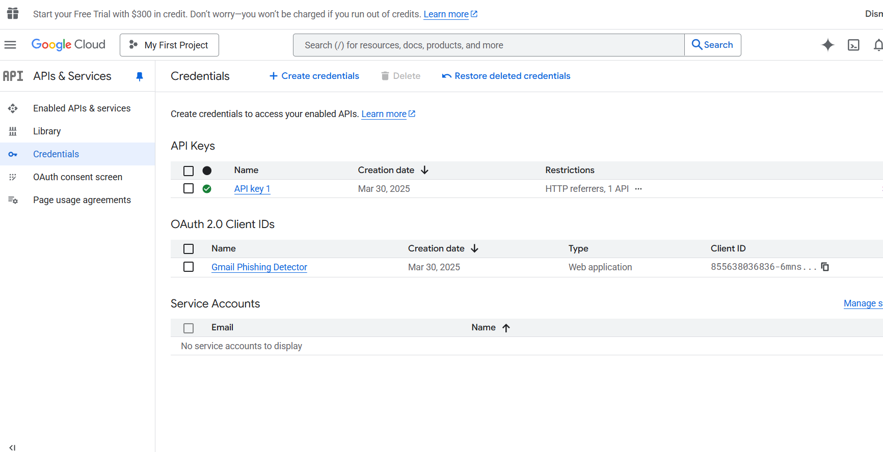
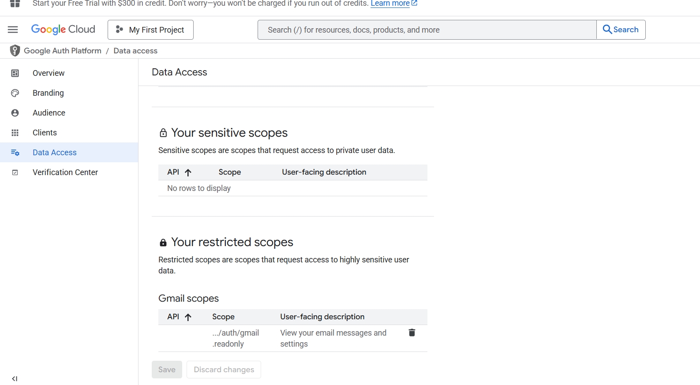
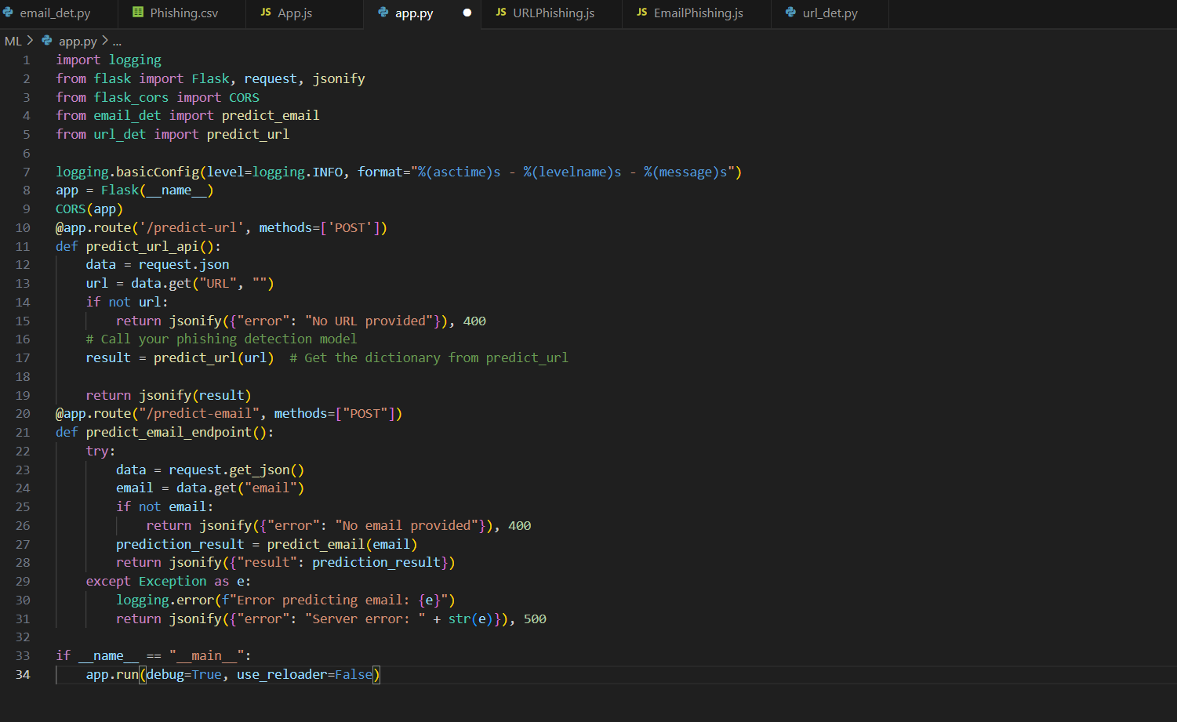
- Email Analysis: The backend extracts email snippets and cleans the text (lowercasing, removing punctuation and hyperlinks). A TF-IDF vectorizer converts this cleaned text into numerical vectors, using both unigram and bigram patterns. These vectors are passed to a logistic regression model, which outputs the probability of the email being phishing.
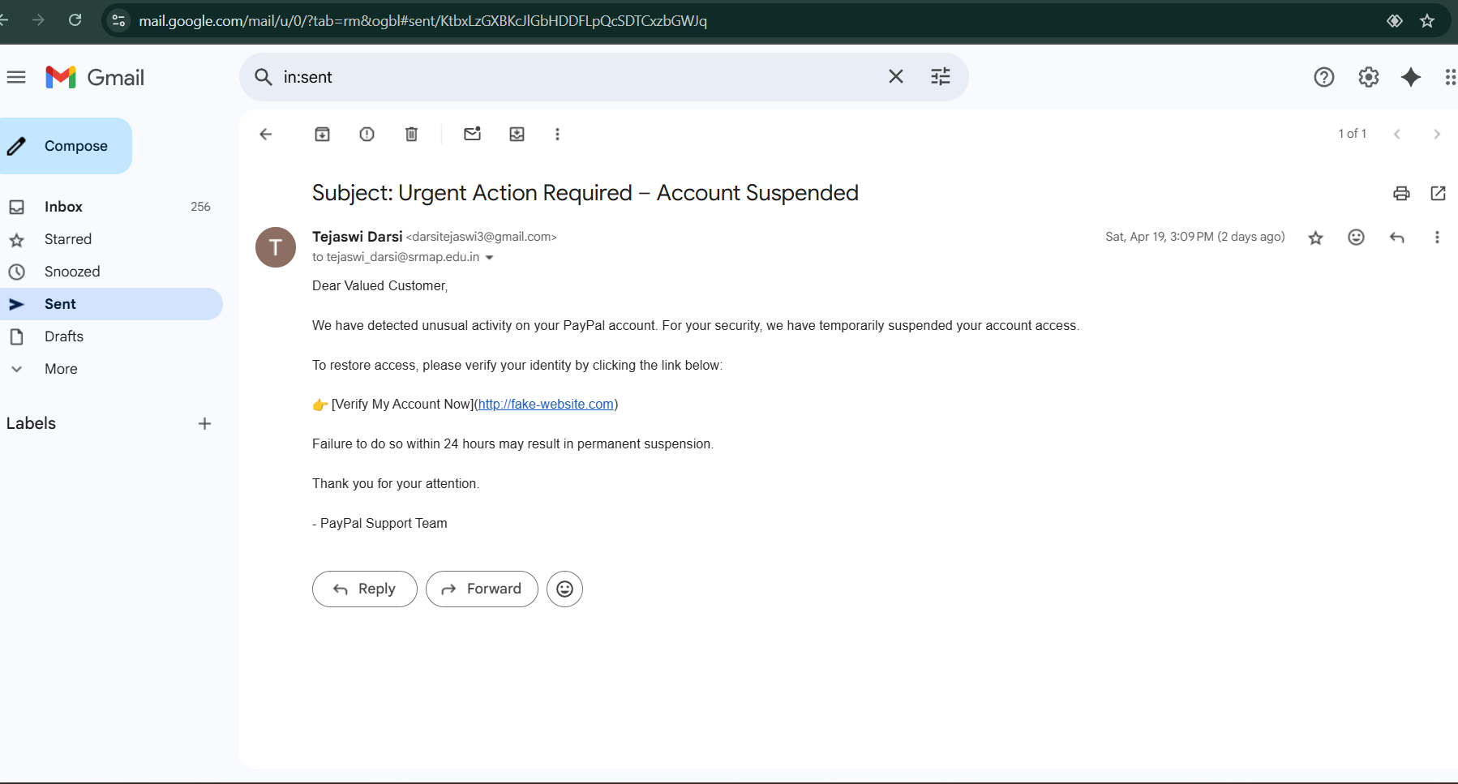
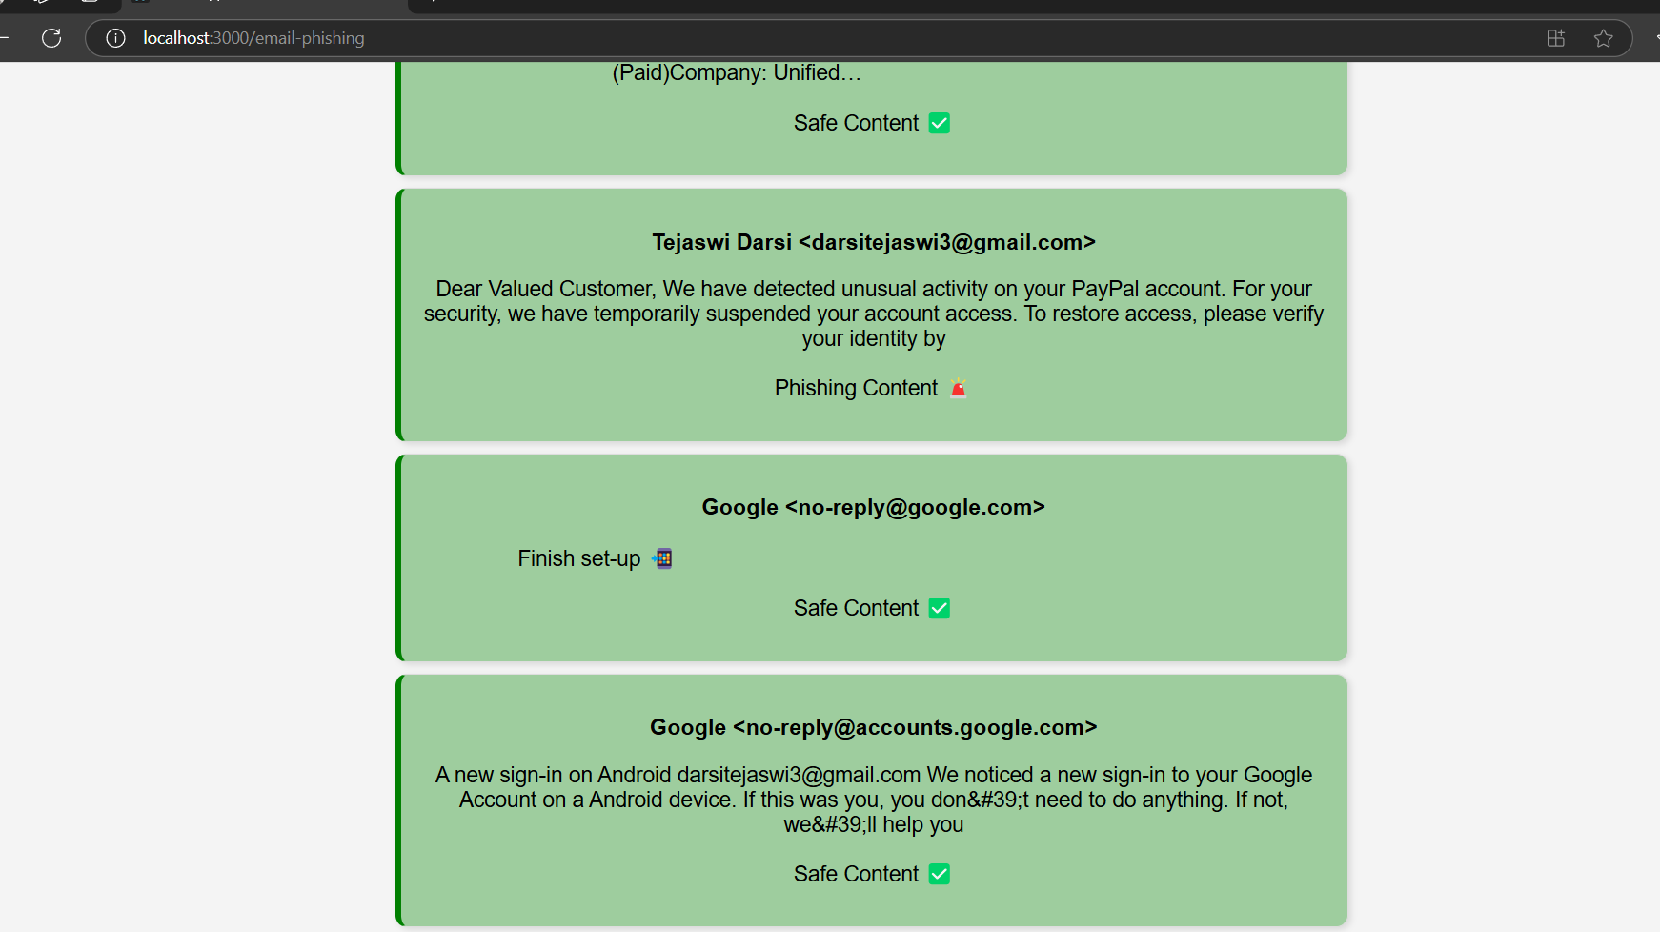
- URL Analysis: URLs are parsed to extract structured features (e.g., presence of HTTPS, length, subdomains, suspicious characters). These features are normalized using StandardScaler. Additionally, the target webpage is scraped using BeautifulSoup to identify keywords such as "login", "verify", and "password". A heuristic score is computed from these findings.
- Prediction and Heuristics: The logistic regression model outputs an initial phishing probability. This output is combined with heuristic indicators (content-based risk score) to generate a final verdict.
- Result Display: The backend sends the results—comprising phishing/safe verdict and associated confidence or risk levels—to the frontend. These are then displayed using color-coded cards (e.g., red for phishing, green for safe, yellow for moderate risk).
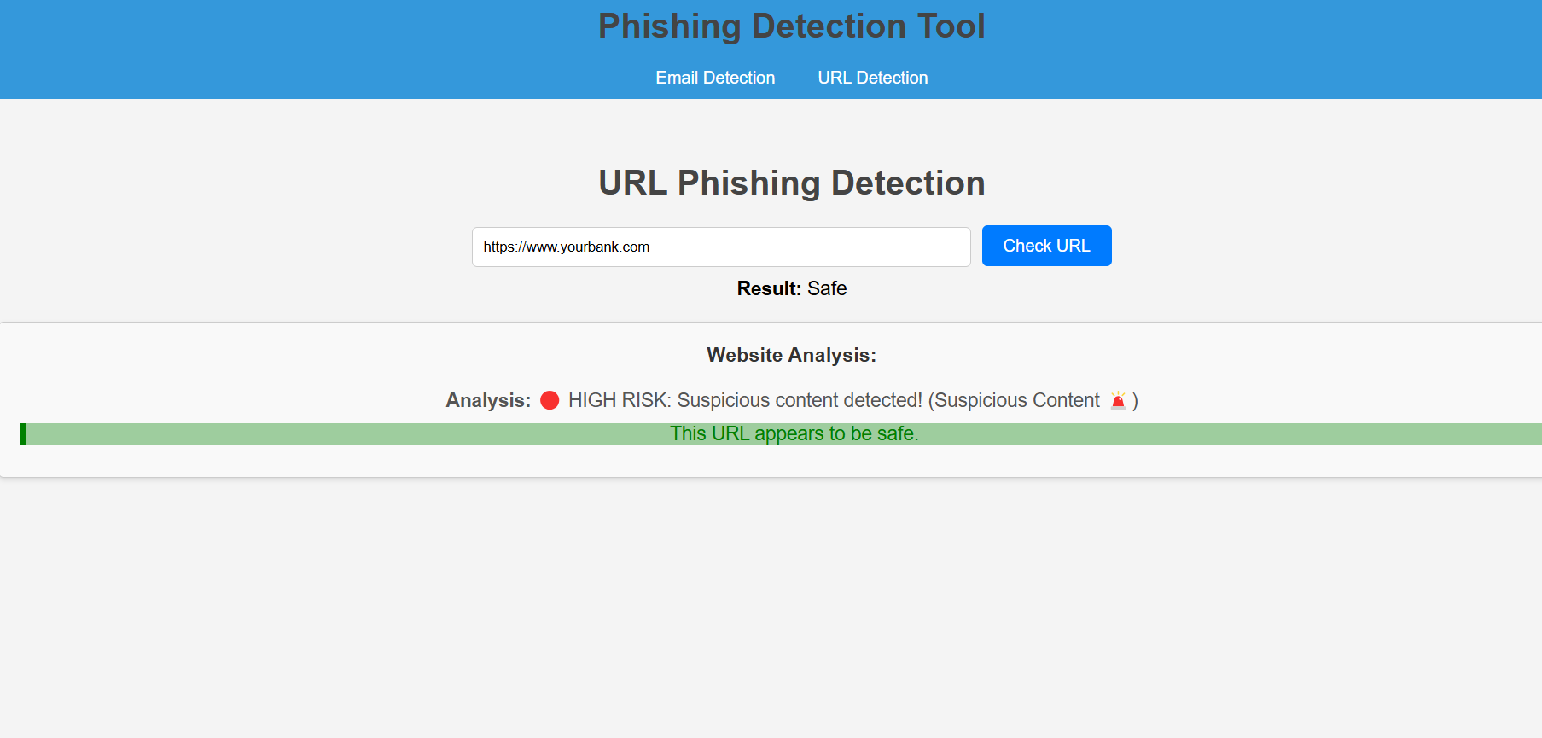
This systematic integration of machine learning with content-based heuristics enhances the reliability of phishing detection across different mediums.
6. System Architecture
- Frontend: Accepts URL input and handles Google OAuth
- Backend: Processes data, applies ML models, returns results
- ML Layer: Handles preprocessing, vectorization, and classification
- Data Sources: Gmail API, User Input, Public Datasets

7. Impact of the Problem if It Is Not Solved
Failure to address phishing threats can lead to:
- Financial Loss: Users and organizations can suffer monetary damage
- Data Breaches: Unauthorized access to sensitive data
- Reputation Damage: Loss of trust and credibility for individuals or brands
- Legal Consequences: Non-compliance with data protection regulations (e.g., GDPR)
- Network Intrusions: Compromise of internal systems and spread of malware
8. Results and Analysis
Email Phishing Detection
The logistic regression model trained for email phishing detection achieved the following results on the test set:
Metric | Value
Accuracy | 90.5%
Precision (Class 1) | 100%
Recall (Class 1) | 77%
F1-Score (Class 1) | 87%
- Interpretation:
The model shows excellent precision, meaning when it predicts an email as phishing, it’s almost always correct. However, the recall indicates it misses some phishing emails. The balance between both is shown in the F1-Score.
URL Phishing Detection
After cleaning and preprocessing, the logistic regression model trained on the URL dataset gave the following:
Metric | Value
Accuracy | 99.98%
Label 0 Count (Safe) | 116,286
Label 1 Count (Phishing) | 100,944
- Interpretation:
The model shows extremely high accuracy, likely due to strong feature engineering (like domain structure, presence of “@”, “//”, use of HTTPS, etc.). The class balance is also fairly good with around 100k+ samples per class, which strengthens model generalization.
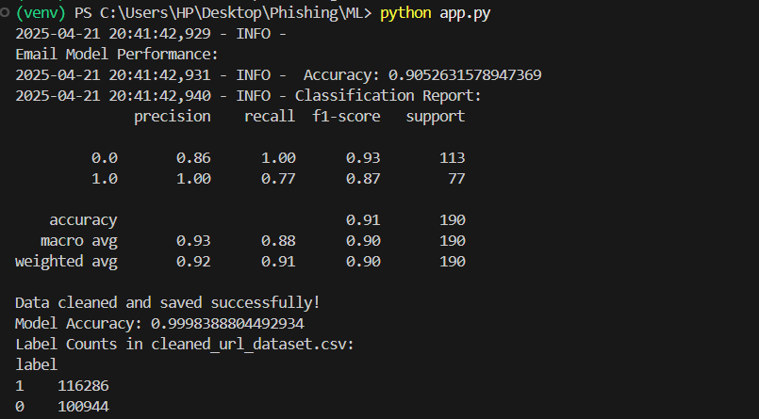

9. Conclusion
The phishing detection tool successfully integrates multiple technologies to address the complex and evolving threat of phishing. It delivers high accuracy in classifying both email and URL-based phishing attempts. With a user-friendly interface and scalable architecture, the system is well-suited for deployment in personal and enterprise environments. Future enhancements may include deep learning models, integration with real-time threat feeds, and browser plugin deployment.

10. References
- UCI Machine Learning Repository – Phishing Websites Dataset
- Gmail API Documentation – Google Developers
- scikit-learn Documentation – https://scikit-learn.org
- BeautifulSoup Library – https://www.crummy.com/software/BeautifulSoup/
- OAuth 2.0 – Google Identity Platform
- TF-IDF Vectorizer – scikit-learn
- Logistic Regression in ML – Towards Data Science

